Project Documentation

----------------------------------------------------

Ask a Manager Salary Survey Analysis

- Project Overview
This project focuses on cleaning, categorizing, and visualizing data from the Ask a Manager Salary Survey to analyze salary patterns across different industries, job roles, and geographic regions. The dataset contains self-reported salary information along with related attributes that require standardization and structuring for analysis. Microsoft Excel was used to clean the raw data by handling missing values, correcting inconsistencies, and categorizing key fields to make the dataset analysis-ready. The cleaned data was then imported into Power BI, where interactive dashboards and visualizations were created to explore salary distributions and identify meaningful trends.
This project demonstrates the use of data cleaning and visualization techniques to convert raw survey data into clear and actionable insights.
- Tools used
• Microsoft Excel
• Power BI Desktop

Dataset
- Source: Ask a Manager Salary Survey.csv (raw dataset)
- Description:
The dataset consists of self-reported salary information collected from professionals across various industries, job roles, experience levels, and geographic regions. The data contains raw survey responses that require cleaning and standardization before analysis.
- Data Contains:
  - Job title
  - Industry
  - Annual salary
  - Currency
  - Country and region
  - Years of experience
  - Employment type
  - Gender
  - Education level

Steps Followed
a. Data Cleaning and Preparation in Microsoft Excel
- Removed duplicate records
- Handled missing and null values
- Standardized column names for consistency
- Corrected data types for numerical and categorical fields
- Removed salary outliers to improve accuracy of analysis
- Re-categorized columns such as Gender and Industry to reduce excessive unique values and group similar entries
- Removed unnecessary and irrelevant columns
b. Data Import into Power BI
- Imported the cleaned dataset into Power BI for further analysis
c. Data Transformation and DAX Implementation
- Created new calculated columns using DAX
- Converted all salary values into USD using currency conversion logic
- Standardized salary values into a single currency (USD) to ensure accurate and equal comparison across countries
d. Dashboard Development
- Built an interactive dashboard using charts, slicers, maps, tables, and KPI visuals
- Enabled analysis of salary trends across industries, regions, gender categories, and experience levels

Key Visualizations
- Cards
  - Country with the highest number of survey entries
  - Age group with the most responses
  - Most common industry among respondents
- Map Visualization - Entry Distribution by Country
  - Displays the geographic distribution of survey responses, highlighting countries with the highest participation.
- Funnel - Average Salary in USD (Top Countries)
  - Shows average salary values (converted to USD) for the top countries with the most survey entries.
- Clustered Column Chart - Salary by Work Type
  - Compares average salaries across different work arrangements such as Remote, Hybrid, and On-site for selected countries.
- Ribbon Chart - Salary by Years of Experience
  - Visualizes how average salary changes with increasing years of experience, with comparisons across selected industries.
- Stacked Bar Chart - Salary by Gender (Higher Education)
  - Compares average salaries across gender categories within the Higher Education industry.
- Donut Chart - Disability Status Distribution
  - Represents the proportion of employees with and without disabilities within the Banking and Finance industry.
- Stacked Column Chart - Unionization Status by Country
  - Shows the distribution of unionized, non-unionized, and unspecified employees across multiple countries.
- Tree Map - Age Distribution Across Industries
  - Displays the proportion of different age groups across industries, helping identify dominant age ranges within each sector.

Key Insights
- The United States has the highest number of survey responses and strongly influences overall trends.
- Average salaries in USD vary across countries, with the US, Switzerland, Ireland, and Australia among the highest.
- Remote and hybrid roles often show higher or comparable salaries than on-site roles.
- Salary increases with years of experience, peaking in the 31- 40 years and 41+ years groups.
- In Higher Education, salary differences exist across gender categories.
- In Banking and Finance, most respondents report no disability, with smaller disabled and uncertain groups.
- Unionization levels differ widely by country.
- The 35-44 age group forms the largest share of respondents.
- Higher Education is the most common industry in the survey.

- Screenshots
Fig.1 Salary survey Dashboard overview
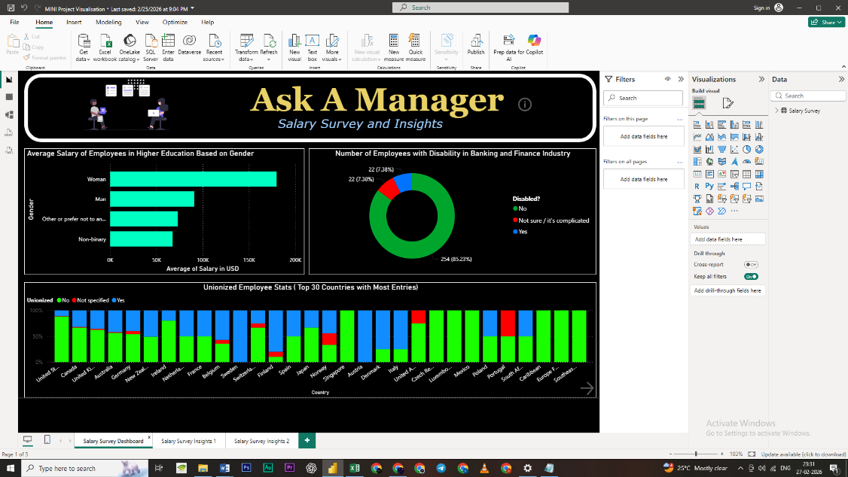

Fig.2 salary Survey Insights 1
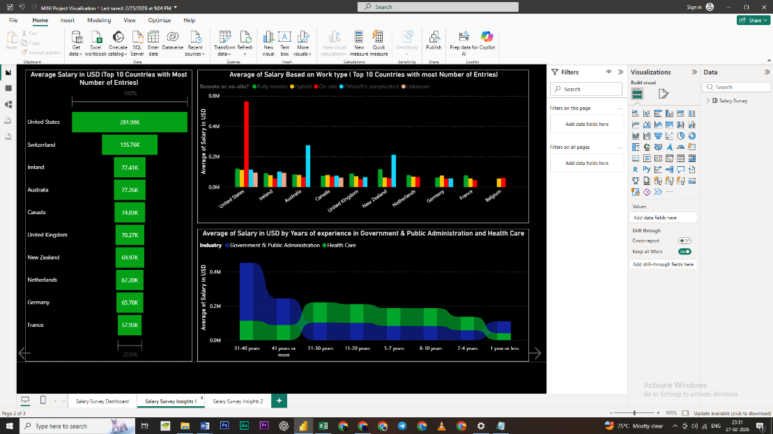

Fig.3 Salary Survey Insights 2
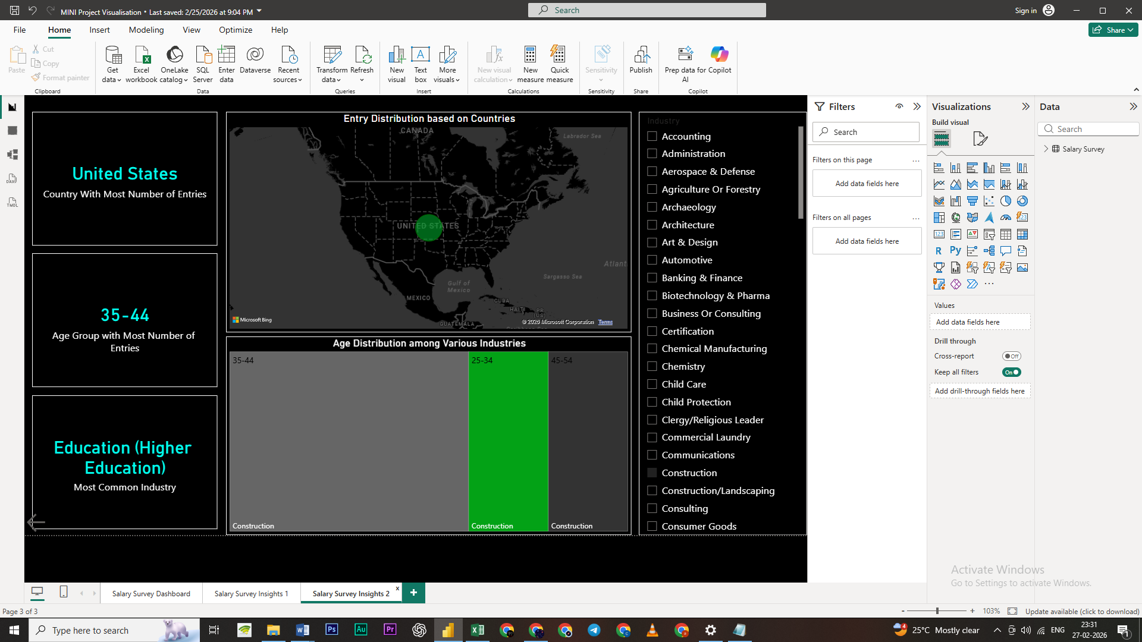

- Files Included
The following files are attached:
- Ask a Manager Salary Cleaned Dataset.xlsx
- Ask a Manager Salary Visualisation.pbix
- README.docx Project Documentation

- How to Use
• Open the Excel file to view the cleaned dataset.
• Open the .pbix file using Power BI Desktop to explore the interactive dashboard.
• Interact with charts to explore dynamic insights.

- Conclusion
This project successfully transformed raw salary survey data into meaningful insights through systematic cleaning, categorization, and visualization. A major challenge was handling raw, random individual entries with inconsistent formats and categories. By standardizing data, removing outliers, and converting all salaries to USD, reliable comparisons were achieved. The Power BI dashboards clearly reveal trends across experience, work type, industry, and geography, demonstrating effective end-to-end data analysis.

◆◆◆

